

**OBJECT ORIENTED PROGRAMMING (OOP)**

**By**

**Sir Usman Ahmed**

**LAB REPORT 2 (BSCS III)**

GITHUB LINK= <https://github.com/miannoorbaho/OOP-LAB>

# GITHUB: [miannoorbaho](https://github.com/miannoorbaho)/[OOP-LAB](https://github.com/miannoorbaho/OOP-LAB)

**Submitted by**

**NOOR BAHO**

**CSU-F12-116**

**DEPARTMENT OF COMPUTER SCIENCE & INFORMATION TECHNOLOGY**

**THE UNIVERSITY OF LAHORE, ISLAMABAD CAMPUS**

**Q1: Write a program of basic calculator (+, -, *, /) using switch statement.**

**Solution:**

#include <iostream>

#include <conio.h>

float add(float x, float y)

{

return x+y;

}

float sub(float x, float y)

{

return x-y;

}

float mul(float x, float y)

{

return x*y;

}

float div(float x, float y)

{

return x/y;

}

using namespace std;

int main ()

{

float a, b;

int mod;

int rep=1;

while(rep>0){

cout<<"Enter 1 to Add, 2 to Subtract, 3 to Multiply, 4 to Divide. : ";

cin>>mod;

switch (mod)

{

case 1:

case 2:

case 3:

{

cout<<endl<<"Enter 1st number ";

cin>>a;

cout<<"Enter 2nd number ";

cin>>b;

break;

}

case 4:

{

cout<<endl<<"Enter 1st number, The dividend: ";

cin>>a;

cout<<"Enter 2nd number, The divisor: ";

cin>>b;

break;

}

}

switch(mod)

{

case 1:

{

cout<<"Result: "<<add(a, b);

break;

}

case 2:

{

cout<<"Result: "<<sub(a, b);

break;

}

case 3:

{

cout<<"Result: "<<mul(a, b);

break;

}

case 4:

{

cout<<"Result: "<<div(a, b);

break;

}

}

cout<<endl<<endl<<"Enter 1 to proceed again, 0 to terminate: ";

cin>>rep;

cout<<endl<<endl;

}

getche();

return 0;

//clrscr();

}

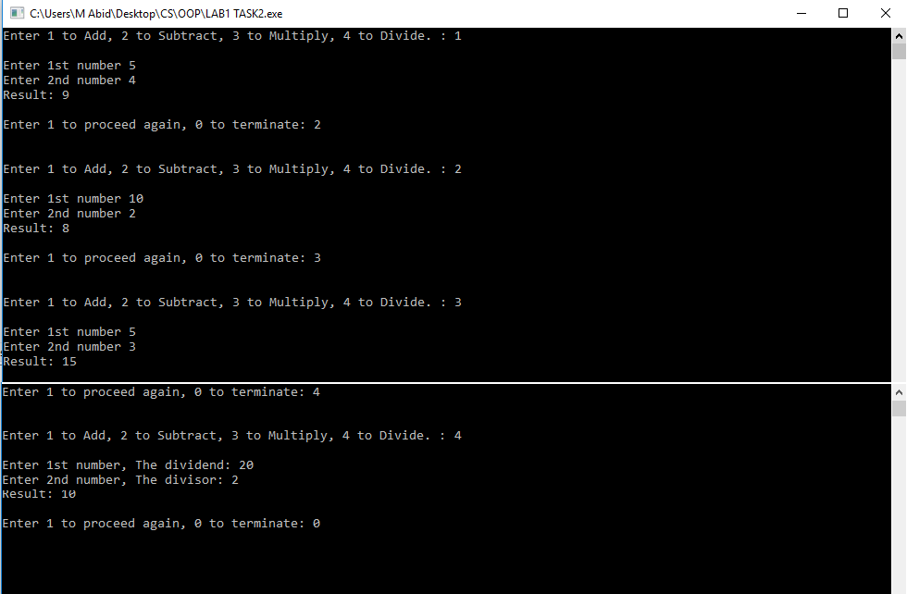

**Figure 2.1**

**Q2: Write a program to find the factorial of a number.**

**Solution:**

#include <iostream>

#include <conio.h>

//factorial finding

using namespace std;

int main()

{

int a, f=1;

cout<<"Enter the number to find factorial: ";

cin>>a;

for(int x=a; x>0; x--)

{

f=f*x;

}

cout<<"Factorial of number "<<a<<" is: "<<f;

getch();

return 0;

}

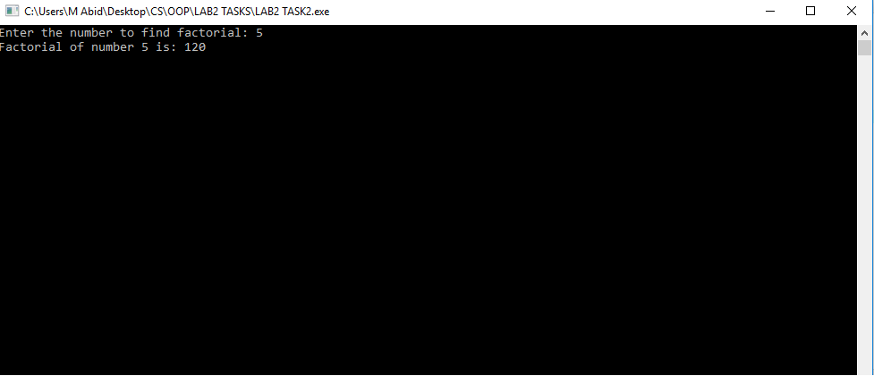

**Figure 2.2**

**Q3: Write a program to print output like: 1, 12, 123, 1234.**

**Solution:**

#include <iostream>

#include <conio.h>

//prints like 1, 12, 123, 1234, 12345 etc

using namespace std;

int main()

{

for(int a=1; a<=9; a++)

{

for(int b=1; b<=a; b++)

{

cout<<b;

}

cout<<endl;

}

getch();

return 0;

}

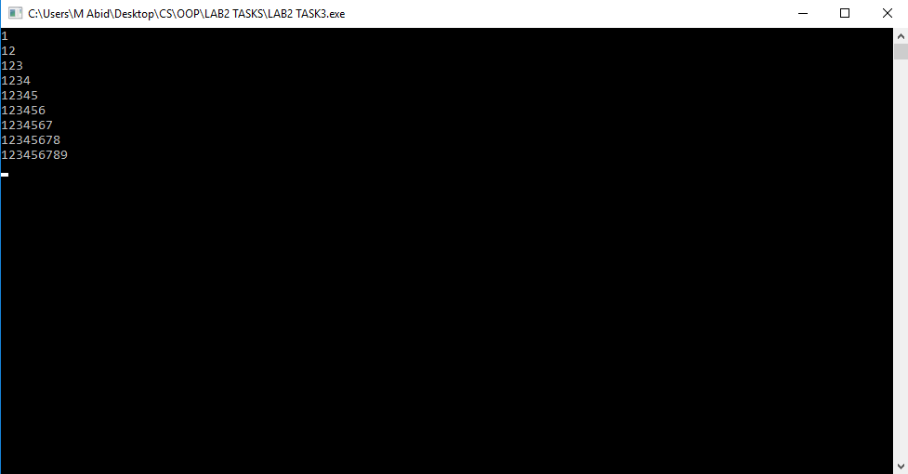

**Figure 2.3**

**Q4: Write a program using loop and continue statement to find sum of even numbers from 1 to n.**

**Solution:**

#include <iostream>

#include <conio.h>

//find sum of even numbers from 1 to n. using loop and continue.

using namespace std;

int main()

{

int num, sum;

cout<<"Enter a number: ";

cin>>num;

for(int x=num; x>=0; x--)

{

if(x%2==0)

sum= sum+x;

}

cout<<"Sum of even numbers from 1 to "<<num<<" is: "<<sum;

getch();

return 0;

}

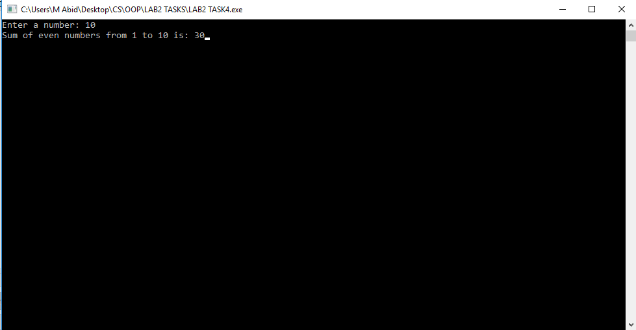

**Figure 2.4**

**Q5: Write a program that reverses an integer number . i.e: 133=331, 987=789.**

**Solution:**

#include<iostream>

#include<conio.h>

//reverse the order of numbers

using namespace std;

int main()

{

int num;

int rnum[2];

cout<<"Enter a 3 digit number: ";

cin>>num;

rnum[0]= num%10; //LAST DIGIT SEGREGATED

rnum[1]= num%100;

rnum[1]= rnum[1]/10; //second digit segregated

//cout<<num; //Debugging statement

rnum[2]= num%1000;

rnum[2]= rnum[2]/100; //first digit segregated

//confusion variable num is changing value at above statement whereas variable num is not used in this statement.

cout<<"Reverse order of "<<num<<" is: "; //variable num is changing value

for(int a=0; a<=2; a++)

{

cout<<rnum[a];

}

getch();

return 0;

}

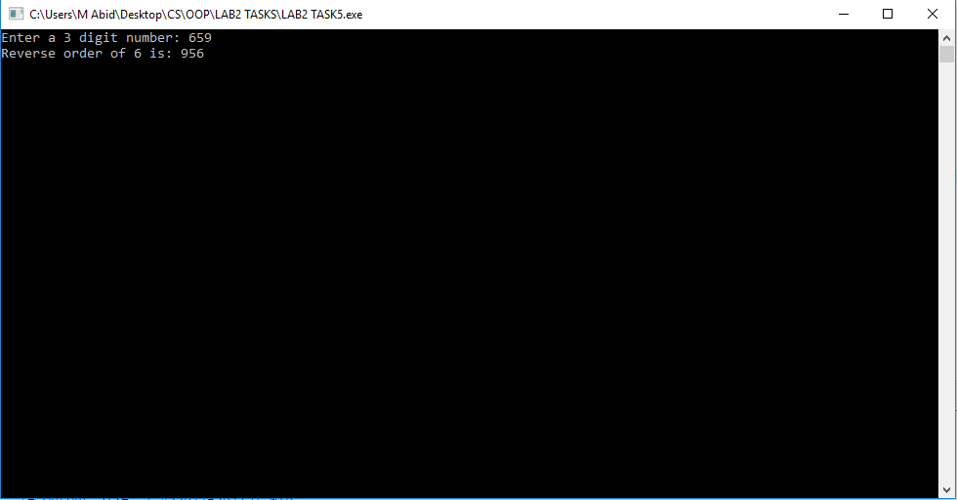

**Figure 2.5**

**Q6: Write a program that sums the digits of a number. i.e: 133=7, 679=22.**

**Solution:**

#include<iostream>

#include<conio.h>

//sums the digits of number

using namespace std;

int main()

{

int num, sum;

int rnum[2];

cout<<"Enter a 3 digit number: ";

cin>>num;

rnum[0]= num%10; //LAST DIGIT SEGREGATED

rnum[1]= num%100;

rnum[1]= rnum[1]/10; //second digit segregated

rnum[2]= num%1000;

rnum[2]= rnum[2]/100; //first digit segregated

sum= rnum[0]+ rnum[1]+ rnum[2];

cout<<"Sum of digits: "<<sum;

getch();

return 0;

}

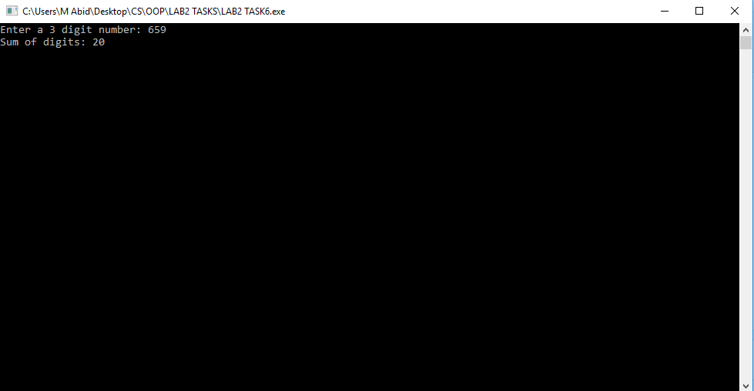

**Figure 2.6**